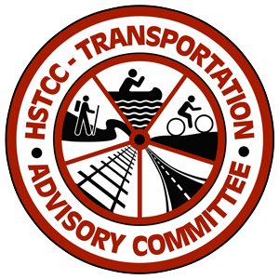

407 S Pennsylvania Ave
Joplin, MO 64804
www.hstcc.org

Phone: 417-625-6611

Transportation Advisory Committee (TAC)
Voting Members of the TAC:
Janice & Dwayne Bearbower (Anderson) | Russ Worsley (Lamar) | Lewis Davis (Noel)
Mike Davis (Barton County) | John Bunch (McDonald County) | Gary Turner (Sarcoxie)
Tom Short (Carthage) | Rachel Holcomb (Neosho) | Cyndy Hutchings (Seneca)
John Bartosh (Jasper County) | Jim Jackson (Newton County)
MEETING AGENDA
August 19, 2020 2:00 PM
Virtual only meeting
https://www.google.com/url?q=https://us02web.zoom.us/j/87883650395?pwd%3DbG04L3VSOTNJSm0rNFA1WnoyUDk1UT09&sa=D&source=calendar&ust=1597844507388000&usg=AOvVaw3NabShvHdQSgPHoWJhGEgu
Meeting ID: 878 8365 0395
Password: 081479
To join by phone: 312-626-6799
- Introductions
- Call to Order
Tom Short, Chair
- Approval of Agenda
- Approval of Minutes
- HSTCC Staff Business & Updates
  - Updating Regional Transportation Plan
  - Missouri Blue Print
  - National Regional Transportation Conference (NADO)
  - Updates from Planning Partners call
  - Community Events
- MoDOT Updates
  - Dave Taylor, Frank Miller, Zeke Hall, Craig Switzer
- MPO Updates
  - Taylor Cunningham- JATSO
- Old Business
Review of TAC prioritization list – updates on projects that needed additional information
- Future Business
a. Adding goals and objectives to RTP
b. Planners to meet with each county individually
c. Guest Speakers
d. Future topics

- Other Member & Guest Updates
- Future TAC Dates*
November 18, 2020
February 17, 2021
May 19, 2021
Have availability to add additional dates as needed.

Possible meeting location to be at Chamber of Commerce until George Washington Carver becomes available.

- Adjourn

*All future meetings will be held at the George Washington Carver National Monument at 3:00 pm (depending on COVID restrictions)

This meeting is conducted in accordance with Missouri’s Sunshine Law and is open to the public. HSTCC fully complies with Title VI of the Civil Rights Act of 1964 and related statutes and regulations in all programs and activities. For more information or to obtain a copy of HSTCC’s Title VI Non-Discrimination and Fair Practice Policy and learn how to file a complaint, please visit www.HSTCC.org or call 417-623-6611.

