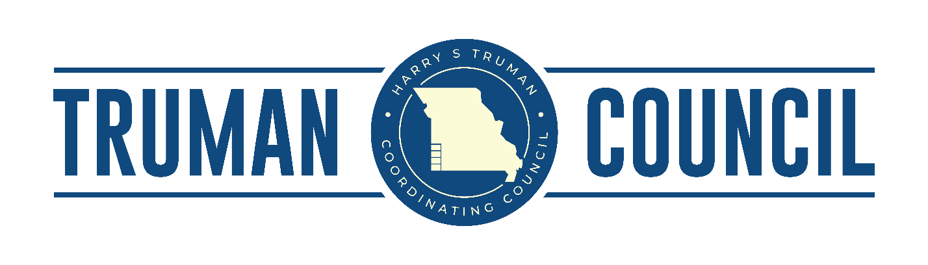

Harry S Truman Coordinating Council
Board & Membership Meeting
Minutes from January 21, 2021– 2 p.m.
Via Zom

HSTCC Executive Committee
John Bartosh, John Bunch, Cyndy Hutchings, Justin Pryor, Gary Shaw, Crystal Winkfield, Debbie Cornell
(7 members total: Missing 6)

Officers: Cyndy Hutchings, Chairperson

ATTENDEES:

Gwen Allen – Webb City Chamber
Pat Bearden – City of Alba
Gerritt Brinks – HSTCC
Carrie Campbell – HSTCC
Melody Cundiff — City of Duquesne
Cody Green – USDA
Zeke Hall – MoDOT
Cyndy Hutchings – City of Seneca
Laura Larmore – Southwest MO Workforce
Gabe Lett – Alleger Martin Associates
Carol Meyer – HSTCC
Ceri Otero – City of Carthage
Weston Rea – Weston’s Tax and Accounting
Sherri Rhuems – Southwest MO Workforce
Tony Robyn – MOKAN/JACC
Dave Taylor –MoDOT
Madelyn Wood – HSTCC
Russ Worsley – City of Lamar
Tyler Marriott – Senator Blunt Field Rep.
Clayton Campbell - Senator Hawley Field Rep
Treva – City of Alba
Bree Pettengill – City of Golden City

Call to Order: Chairperson Cyndy Hutchings called the meeting to order at 2:10 p.m.

Consent Agenda: No quorum, could not vote for approval.

Minutes of the Previous Meeting: No quorum, could not vote for approval.

Executive Director’s Report: Executive Director Gerritt Brinks presented the new staff member Kasei Lewis, the Economic Recovery Coordinator and Environmental Planner. He went over the grants HSTCC has applied for—3 Bureau of Justice Grants for Neosho, Westview C-6, and Carthage; Neosho MIT-4317; and USDA Planning Grant—along with the two newly funded projects, the Southwest City Drinking Water (CDBG) project and the Duquesne recreational Trails Program (RTP). He also updated members on the current CDBG and SEMA projects, of grants that are in the works, and recent comprehensive plans. Potential awards of more CBDG grants would mean HSTCC could hire another planner.

Financial Reports: Fiscal Officer Carrie Campbell presented the financial history of the organization and informed the membership of the new accounting system that has saved the company roughly $20,000. She stated that HSTCC is doing very well as only 41.80% of the budget has been used, while staying under the 25-50% expected budget range and averaging 23.4% per quarter. Accounts have been reconciled through November and signed off on by accountant and executive director. December has a software issue that is being resolved with coding. Accountant has been involved. GMS is working hard to get it fixed. Quarterly invoices for MoDOT, EDA, and EDA CARES have been submitted. Total Drawdowns for this quarter: $73,018.57. MoDOT drawdown has been submitted for a total of $17,578.64. Funds have not been deposited yet. Cash flow had an increase of $22,750.58 due to:
- Mo State Admin (additional funding) $4450.58
- Webb City Housing Auth Environmental Review $4300
- Lanagan Water Project: $14,000
Additionally, currently working on finishing the Jasper/Newton County Mitigation Plan and will be finished by
the first week of February.

Accountant Update: Weston Rea from Weston’s Tax and Accounting LLC informed that the audit came back with no issues and everything was looking correct and matching up. ?

Legislative & Member Reports:

Gwen Allen, Webb City—Webb City is regrouping and reorganizing with the effects of COVID. The city and chamber of commerce are looking for a new building to be used as a small business resource center. The city is also experiencing lots of growth and development, several new businesses are planned to be opening in the Centennial Retail Park along with more renovations in downtown.

Pat Bearden, Alba—The ballpark project became too expensive, so the city abandoned that project, but will use the funding for other projects.

Clayton Campbell, Senator Hawley Rep.—New administration promising new legislative; lots of executive activity.

Tony Robyn, MOKAN—Still prospering despite COVID—lots going on; several big projects. Refresco will be expanding. Also, the training program with crowder College is in the works. Working closely with the railroad and their leadership along with Crossroads industrial park.

Cyndy Hutchings, Seneca—City Hall is currently under lock down due to the number of COVID cases internally; members are planned to receive COVID vaccines. All projects have been paused until further notice.

Laura Larmore, Southwest MO Workforce—A virtual job fair will be held June 2021.

Gabe Lett, —Happy to serve the community, had a good year in 2020 despite COVID and is looking forward to 2021.

Ceri Otero, Carthage—Butterball is dropping to only 300 employees due to COVID, normally they have 800+. Schreiber’s plans to expand and a round about is scheduled to be put on main road heading to Schreiber’s to aid in traffic congestion. Many grants and projects will be soon to happen.

Bree Pettengill - Recently took over the city clerk position. Received laptops through CARES for the board. Looking to do housing—several people are looking forward to invest in property.

Next Meeting: To be determined.

Adjourn: Meeting adjourned by Cyndi Hutchings at 3:06 p.m.

